# Instructions of the translation tool

## Precondition

Please ensure .Net Framework 4.0 has been installed on your machine, otherwise the tool can’t be executed. You can download the Web Installer here:

<http://www.microsoft.com/download/en/details.aspx?id=17851>

## Steps

1. Extract the *.zip package to your disk of your local machine.
2. Execute TranslationTool.exe
3. Select an item in the left list, and the entries of this item appear in the right hand side.
4. Translate the text in these textboxes, after done click “Save” button.
5. Repeat the step 3/4, and select another item in the left list until you have completed all the translation.
6. Compress the files and send back.

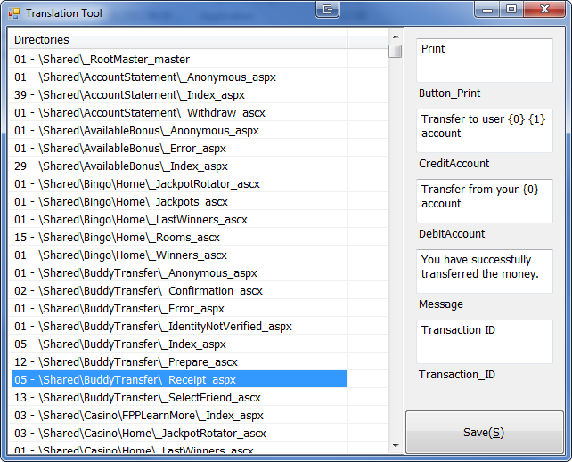

## Attention

1. DO NOT edit the files/directories directly on the disk
2. DO NOT change the directory structure after you extract the package to your disk
3. The place holder ({0} / {1} / …) exists in some text, which will be replaced dynamically when the text is presented. Hence, please keep the place holder in the translated text. And you need avoid to use brace( { / } ) in this kind of text. For example:

* English: Transfer to user **{0} {1}** account
* Translated: 充值到您的 **{0} {1}** 账号

1. If HTML tags appear in the text, you should only translate the text and avoid to break the HTML code. For example.

* English: By entering a bonus code, you agree to the bonus <a id="lnkBonusTermsConditions" href="#" target="_blank">Terms &amp; Conditions.</a>
* Translated: 输入优惠码表示您同意优惠<a id="lnkBonusTermsConditions" href="#" target="_blank">条款</a>

1. DO NOT change / translate **[Metadata:???]** expression in the text. For example

* English: Please note that your deposit will be processed by OddsMatrix Ltd, the payment operator of

**[Metadata:htmlencode(/Metadata/Settings.Operator_DisplayName)]** website , you will see OddsMatrix appearing on your account statement.

* Translated: 注意, 你的充值将会由OddsMatrix处理，它是**[Metadata:htmlencode(/Metadata/Settings.Operator_DisplayName)]** 的运营商，所以你将会看到OddsMatrix出现在你的账单上。